Name : v.supriya
Reg no :- 19247340
Course code :- CSA1616
Course Name:- Data Warehousing and Data Mining

EXPERIMENT-12
1.Covariance and correlation Children of three ages are asked to indicate their preference for
three photographs of adults. Do the data suggest that there is a significant relationship
between age and photograph preference? What is wrong with this study? Photograph: Age of
child A B C 5-6 years: 18 22 20 7-8 years: 2 28 40 9-10 years: 20 10 40 1. Use cov() to
calculate the sample covariance between B and C. 2. Use another call to cov() to calculate the
sample covariance matrix for the preferences. 3. Use cor() to calculate the sample correlation
between B and C. 4. Use another call to cor() to calculate the sample correlation matrix for
the preference.

Aim:- To show the .Covariance and correlation Children of three ages are asked to indicate
their preference for three photographs of adults.
Algorithm :-
1. Take the values of B and C.
2. Find the mean of B and the mean of C.
3. Subtract the mean from each value (get deviations).
4. Multiply the deviations of B and C for each pair.
5. Add all products.
6. Divide by n – 1 → this gives the sample covariance.
Code:-
# Preference data for photographs A, B, C
A <- c(18, 2, 20)
B <- c(22, 28, 10)
C <- c(20, 40, 40)

# 1. Sample covariance between B and C
cov(B, C)
# 2. Sample covariance matrix for A, B, C
prefs <- data.frame(A, B, C)
cov(prefs)
# 3. Sample correlation between B and C

cor(B, C)
# 4. Sample correlation matrix for A, B, C
cor(prefs)
output:- 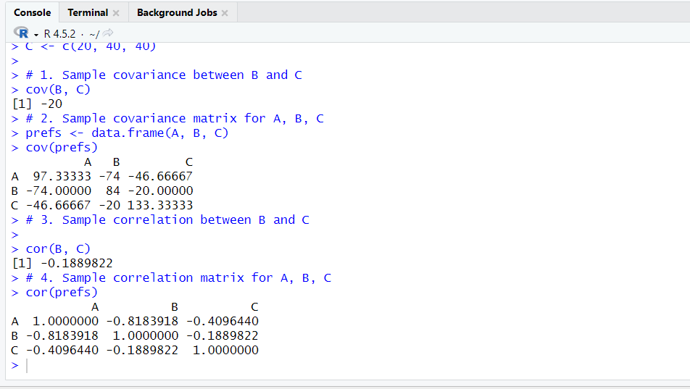
Result:- It is executed successfully.

Experiment-13
2.Imagine that you have selected data from the All Electronics data warehouse for analysis.
The data set will be huge! The following data are a list of All Electronics prices for
commonly sold items (rounded to the nearest dollar). The numbers have been sorted: 1, 1, 5,
5, 5, 5, 5, 8, 8, 10, 10, 10, 10, 12, 14, 14, 14, 15, 15, 15, 15, 15, 15, 18, 18, 18, 18, 18, 18, 18,
18, 20, 20, 20, 20, 20, 20, 20, 21, 21, 21, 21, 25, 25, 25, 25, 25, 28, 28, 30, 30, 30. (i)
Partition the dataset using an equal-frequency partitioning method with bin equal to 3 (ii)
Apply data smoothing using bin means and bin boundary. (iii) Plot Histogram for the above
frequency division
Aim:- To divide the given price data into equal-frequency bins, apply data smoothing (bin means &
bin boundaries), and draw a histogram using R.
Algorithm :-
1. Equal-frequency partitioning
1. Read the sorted data.
2. Decide number of bins = 3.
3. Count total items.
4. Compute items per bin = total / 3.
5. Divide the data into 3 bins with equal number of values
2.Data smoothing
A. Bin Mean
1. For each bin, calculate the mean.
2. Replace every value in the bin with the bin’s mean.
B. Bin Boundary
1. For each bin, find the minimum and maximum value.
2. Replace each value with the nearest boundary (min or max)
3.Histogram
1. Read the price data.
2. Use the hist() function to plot a histogram.
3. Label the axes.
Code:-
# Data
price <- c(1,1,5,5,5,5,5,8,8,10,10,10,10,12,14,14,14,
15,15,15,15,15,15,18,18,18,18,18,18,18,18,

20,20,20,20,20,20,20,21,21,21,21,25,25,25,
25,25,28,28,30,30,30)
# (i) Equal-frequency partitioning (3 bins)
n <- length(price)
bin_size <- n / 3
bins <- split(price, ceiling(seq_along(price)/bin_size))
bins
# (ii) Smoothing
# A. Bin Mean
bin_means <- lapply(bins, function(b) rep(mean(b), length(b)))
bin_means
# B. Bin Boundary
bin_boundary <- lapply(bins, function(b){
lower <- min(b)
upper <- max(b)
sapply(b, function(x)
if(abs(x-lower) < abs(x-upper)) lower else upper)
})
bin_boundary
# (iii) Histogram
hist(price, main="Price Histogram",
xlab="Price", ylab="Frequency")
output:-
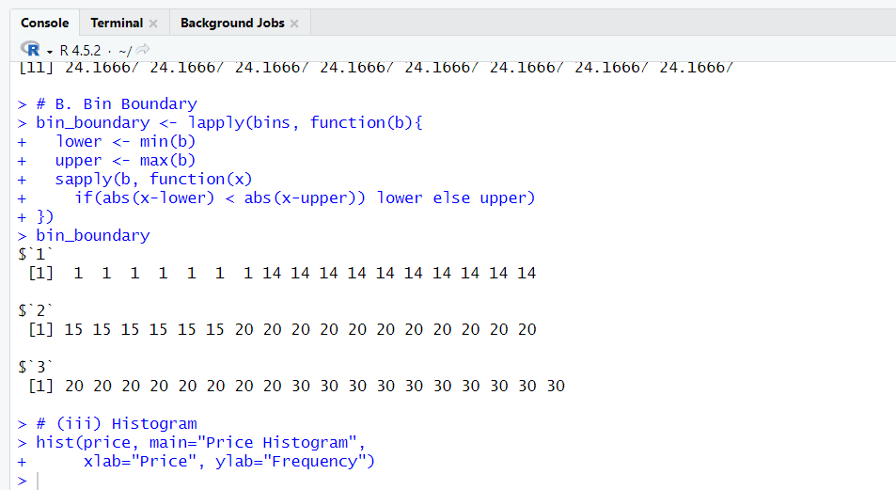
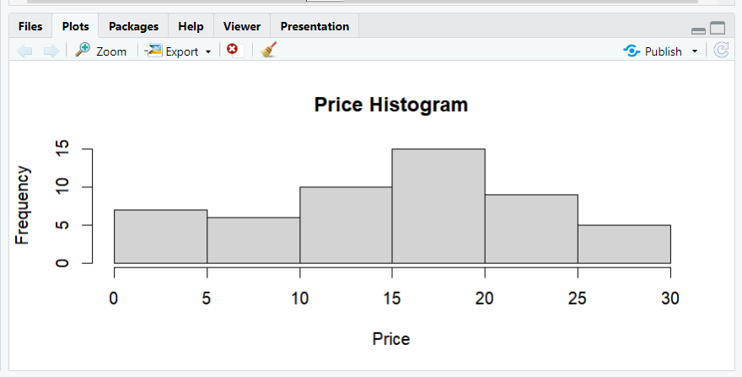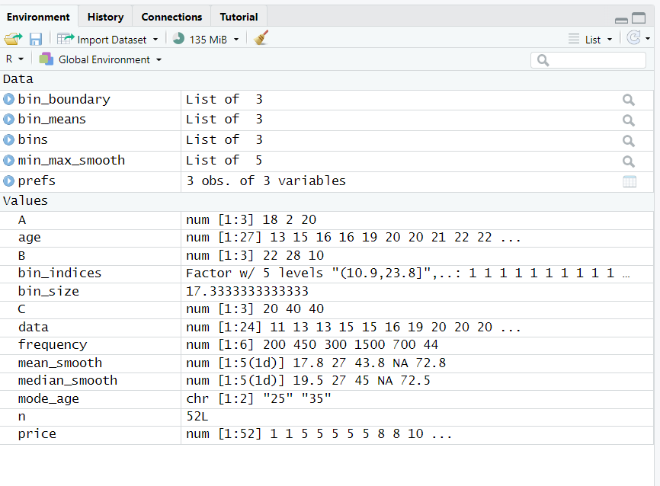
Result:- It is executed successfully.

